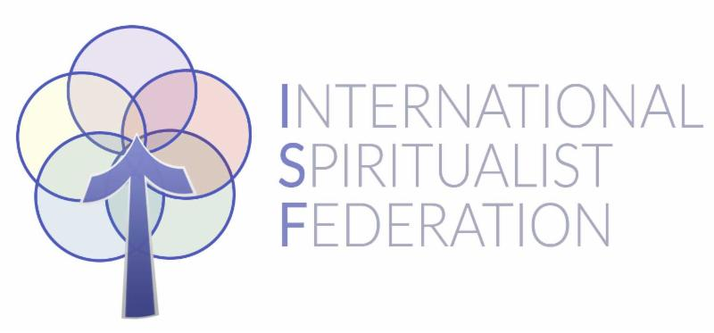
ISF in France 2026
9th April 2026 | 10th April 2026 | 11th April 2026 | 12th April 2026 | 13th April 2026
 | Choice of Meditation or Yoga –  7.30 | Choice of Meditation or Yoga -7.30 | Choice of Meditation or Yoga -7.30am | Choice of Meditation or Yoga -7.30am
 | Breakfast – 8.00-9.00 | Breakfast – 8.00-9.00 | Breakfast – 8.00-9.00 | Breakfast – 8.00-9.00
 | Group work  9.30-11.00 | Group work  9.30-11.00 | Group work  9.30-11.00 | Departure with packed lunches for the journey home
 | Tea/Coffee Break  11.00 – 11.30 | Tea/Coffee Break  11.00 -11.30 | Tea/Coffee Break  11.00 – 11.30
 | Group work  11.30 – 13.00 | Group work  11.30 – 13.00 | Group work  11.30 – 13.00
 | Lunch – 13.00 – 14.00 | Lunch – 13.00 – 14.00 | Lunch – 13.00 – 14.00
Arrival in afternoon  Registration from 15.30 | Group work  14.30 – 16.00 | Group work  14.30 – 16.00 | Group work  14.30 – 16.00
Tea/Coffee Break  16.00 – 16.30 | Tea/Coffee Break  16.00 – 16.30 | Tea/Coffee Break  16.00 – 16.30 | Tea/Coffee Break  16.00 – 16.30
Free Time to Explore | Free Time | Free Time | Free Time
Dinner – 18.00 – 19.00 | Dinner – 18.00-19.00 | Dinner – 18.00 – 19.00 | Dinner – 18.00 – 19.00
Welcome, Introduction to Musicians and Tutors and discussion regarding the purposes of this event -  19.30-21.00 | Evening demonstration of trance  19.30 – 21.00 | Evening demonstration of trance  19.30 – 21.00 | Musical Evening  19.30 – 21.00
Relaxation | Relaxation | Relaxation | Relaxation

